

GR.PY.06 Approval Request Form for External Staff of Mahidol University

For Thesis Committee of Master Degree Student

Year (A.D.)

Proposer (Major Advisor)
proposes the following external staff of Mahidol University:
Lect. / Asst. Prof. / Assoc. Prof. / Prof. / Dr.
From Institute
To be a member / a part of thesis committee as:
 Thesis Proposal Committee
 Co-Advisor
 Chair of Thesis Defence  Member of Thesis Defence
Educational Background
Educational Level | Degree and Major Subject | Year of Graduation | University / Institute
Doctorate Degree
Master Degree
Bachelor Degree
Others
Student Information:
Name-Surname (Mr./ Mrs. / Miss /Ms.) Student No.
Program
Thesis Title:

The following academic papers have been published according to the Office of the Civil Service Commission (OCSC) regulation
- Academic journals accepted by National databases. The papers, at least 10 articles, are related to the thesis title OR
- Academic papers have been published in academic journals accepted by International databases. The papers, at least 5 articles, are related to the thesis title.
1.
List in
 International Database is
 National Database: Thai-Journal Citation Index (only in TCI 1 and TCI 2)
 Related with Thesis (Please Specify)
2.
List in
 International Database is
 National Database: Thai-Journal Citation Index (only in TCI 1 and TCI 2)
 Related with Thesis (Please Specify)
3.
List in
 International Database is
 National Database: Thai-Journal Citation Index (only in TCI 1 and TCI 2)
 Related with Thesis (Please Specify)
4.
List in
 International Database is
 National Database: Thai-Journal Citation Index (only in TCI 1 and TCI 2)
 Related with Thesis (Please Specify)
5.
List in
 International Database is
 National Database: Thai-Journal Citation Index (only in TCI 1 and TCI 2)
 Related with Thesis (Please Specify)
6.
List in
 International Database is
 National Database: Thai-Journal Citation Index (only in TCI 1 and TCI 2)
 Related with Thesis (Please Specify)
7.
List in
 International Database is
 National Database: Thai-Journal Citation Index (only in TCI 1 and TCI 2)
 Related with Thesis (Please Specify)
8.
List in
 International Database is
 National Database: Thai-Journal Citation Index (only in TCI 1 and TCI 2)
 Related with Thesis (Please Specify)
9.
List in
 International Database is
 National Database: Thai-Journal Citation Index (only in TCI 1 and TCI 2)
 Related with Thesis (Please Specify)
10.
List in
 International Database is
 National Database: Thai-Journal Citation Index (only in TCI 1 and TCI 2)
 Related with Thesis (Please Specify)

The above publication are:
1. Not a partial fulfilment of degree completion or graduation
2. Not in Beall's List: Predatory Open-Access Publishers (You can check Publisher in https://beallslist.weebly.com/)

I hereby certify that the above information is true.

Sign Sign
( ) ( )
Propose Member Proposer
Date Date

Recommendation of the Program Director from Program Administrative Meeting Date

Sign
( )
Program Director
Date
Remark:This form has been approved from Faculty of Pharmacy Graduate Committee on Drecember 16, 2020
Instruction
1. After filling in this form, please submit the form and relevant document to Division of Graduate and Post-Graduate Studies, Faculty of Pharmacy for checking
2. Submit to propose member to sign his/her signature
3. Once the document is complete, please submit the document to Division of Graduate and Post-Graduate Studies, Faculty of Pharmacy again to submit to the Program Committee
4. Division of Graduate and Post-Graduate Studies, Faculty of Pharmacy receives a conclusion and/or resolution of the Program Committee
Example
A research paper/publication as an evidence in International Database accepted by the Office of the Civil Service Commission (OCSC) list in attachment page.
1. Scopus
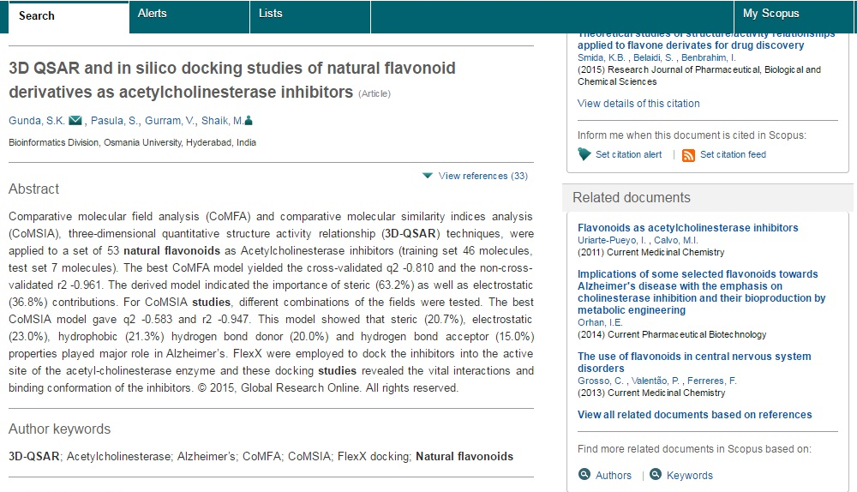
2. Pubmed
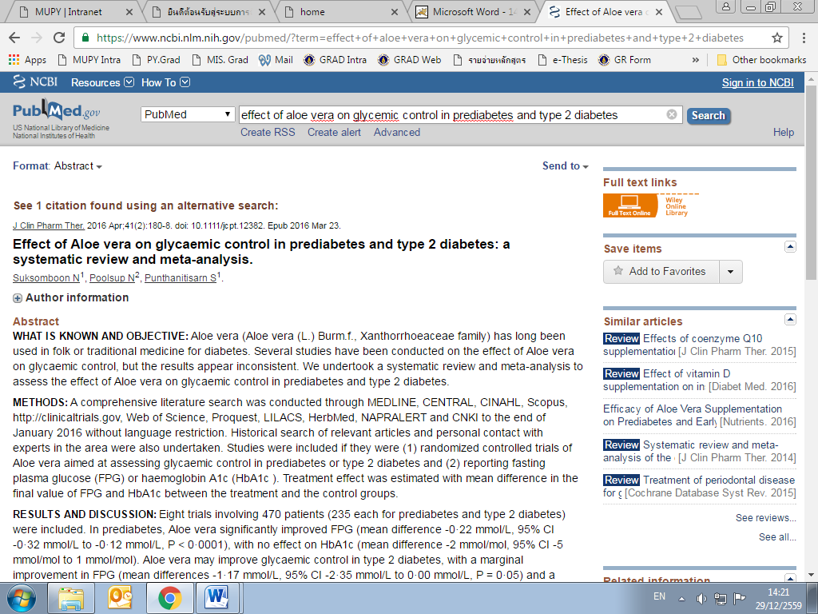

ATTACHMENT
Academic journals that follow the guidelines set by OCSC such as journals whose names are in the database that is recognized nationally and internationally are as follows.
1. Internation Database
- ERIC (http://www.eric.ed.gov/)
- MathSciNet (http://www.ams.org/mathscinet)
- Pubmed (http://www.ncbi.nlm.nih.gov/pubmed/)
- Scopus (http://www.info.scopus.com)
- Web of Science (Only in the database SCIE, SSCI and AHCI) (http://wokinfo.com)
- JSTOR (https://www.jstor.org/)
- Project Muse (https://muse.jhu.edu/)

2. National Database
- Thai Journal Citation Index -- TCI) Specialized journal in the group 1 and group 2.
(http://www.kmutt.ac.th/jif/public_html/list%20journal.php)

Note: In case list of International Database accepted by OCSC is changed, there will be further announced.
Bibiography:
1. The Government Gazette (http://www.ratchakitcha.soc.go.th/RKJ/announce/search.jsp)
2. The Office of the Civil Service Commission (OCSC) (http://www.ocsc.go.th/)
3. Ratchakitcha (http://www.ratchakitcha.soc.go.th/DATA/PDF/2562/E/151/T_0013.PDF)

