Guidelines for Preparing the Final Report of Research Projects Supported by the Fundamental Fund, Mahidol University
The preparation of the final report consists of three parts as follows:
- Final Report
- Financial Report (BRF-03.1)
- Executive Summary (BRF-03.2)
The electronic file of three parts must be submitted through the research unit of Faculty/Institute in both Word and PDF formats, either saved on a data storage device or sent via email to ffmurex@gmail.com. Hard copy submission is not required. Please use the
TH SarabunPSK font, 16-point font. All images and charts must be in color only.

Contents of the Final Report
A. Front Section
- Cover Page (Cover)
Indicate: “Final Report, Mahidol University” – project title in both Thai and English, the name of the principal investigator, research team names, affiliation, the month and year (B.E.) of the report preparation. Additionally, include the following acknowledgement statement in Thai: “งบประมาณสนับสนุนงานมูลฐาน (Fundamental Fund) ประจำปีงบประมาณ พ.ศ. .............. จากกองทุนส่งเสริมวิทยาศาสตร์ วิจัยและนวัตกรรม”
- Acknowledgement
This section expresses gratitude to those who supported or assisted during the study. Please include the acknowledgement statement either in Thai or English as follows:
Thai acknowledgement:
“โครงการวิจัยได้รับการสนับสนุนงบประมาณจากมหาวิทยาลัยมหิดล (งบประมาณเพื่อสนับสนุนงานมูลฐาน ปีงบประมาณ พ.ศ. ....... จากกองทุนส่งเสริมวิทยาศาสตร์ วิจัยและนวัตกรรม (กองทุนส่งเสริม ววน.))”
English acknowledgement:
“This research project has been supported by Mahidol University (Fundamental Fund: fiscal year ........ by National Science Research and Innovation Fund (NSRF)).”
- Abstract (in Thai and English) and Keywords
Provide abstracts in both Thai and English, not exceeding one A4 page. The content should concisely, accurately, and clearly state the objectives, research methodology, and significant research findings. The last line of the abstract must include the keywords of the research.
- Table of Contents
The titles listed in the table of contents must correspond exactly to the titles of the sections in the body of the report.
- List of Table
The titles listed in the list of tables must correspond exactly to the titles of the tables in the body of the report.
- List of Illustrations
The titles listed in the list of illustrations must be correspond exactly to the titles in the body of the report.
- List of Abbreviations and Symbols Used in the Research

B. Main Section
- Introduction
Specify the content of previous research, the significance and background of the research problem, research objectives, scope of the research, theories and/or conceptual frameworks applied, and the expected benefits.
- Research Methodology
Provide details of the research instruments and procedures (Materials & Methods). This may include graphs, tables, and images that can explain, communicate, and organize information for easy understanding or to emphasize important issues.
- Results
Present the research findings in detail, ensuring consistency with the stated research objectives.
- Discussion
Present the reasoning for the research results from section 3 based on academic principles, both for findings that align and do not align with the initial hypothesis. If other documents are referenced in this section, follow the citation principles mentioned in the Introduction.
- Conclusion and Recommendations
Summarize the key findings of this research and propose recommendations regarding future research directions. This may include solutions to problems and obstacles encountered, connections to research and development for further studies, as well as suggestions on practical applications and utilization of the research outcomes.

C. End Section
- Bibliography
List all reference documents, starting with Thai-language references followed by foreign-language references, ordered according to a standard citation style.
- Appendix (if any)
This section is optional. The appendix presents additional detailed information from the research content, intended to prevent the main report from being too lengthy and to provide links to important research details. It may include raw data, questionnaires, and CVs of the project leader and co-researchers, etc.

Sample Final Report Cover Page



Final Report
Mahidol University
“Project Title in Thai”
Project Code can observe by ORIIS.
“Project Title in English”
(Project Code ...........................)

By

.................... Name of Principal Investigator....................
Names of Research Team Members
Affiliation(s)

Month ...................... Year .....................

Fundamental Fund
Fiscal Year B.E. ..............
By National Science Research and Innovation Fund

Financial Report of a Research Project Supported by
BRF-03.1
the Fundamental Fund for Fiscal Year B.E. ..............
Project Title...................................................................................................................................................
Principal Investigator ................................................................................ Affiliation.......................................

Category | Budget per Contract  (1) | Budget Received (Installments 1 & 2) (2) | Actual Expenses  (3) | Remaining  (or overspent) Budget  (4) = (2) - (3)
1. Operating Expenses: Wages
2. Operating Expenses: Supplies
3. Operating Expenses: Materials
4. Investment Budget: Equipment
Total

Notes:
1. For the final installment disbursement, the project must report the actual expenditures incurred up to the present, including any financial commitments made.
2. If requesting the final installment disbursement due to outstanding financial obligations, please attach the corresponding invoice(s) for the requested amount or provide detailed documentation of such obligations to support the consideration. These documents must be certified by the Finance Division of the responsible faculty/department, stating: “It has been verified that these expenditures or obligations were incurred within the certified project period and are pending disbursement from the final installment.”
3. Please submit all spending receipts, financial reports, and project accounts to the finance division of faculty/institute for verification before forwarding them to the university.

Signature.............................................. (..........................................................)  Departmental Finance Officer  Date............................................ | Signature.............................................. (..........................................................)  Principal Investigator  Date............................................

Executive Summary
BRF-03.2
Research Project Supported by the Fundamental Fund
Fiscal Year ……………
The Executive Summary should concisely present the essential content of the main report, providing an overview for committee review. Please fill in the information concisely, clearly, and completely for all sections.

Project Title (Thai)......................................................................................................................................
(English).................................................................................................................................
Principal Investigator ..................................................... Affiliation..............................................................
Allocated Budget Amount..............................Baht
Project Duration.................Years From.......................................To.............................................

Background and Significance
……………………………………………………………..…….…………………………………………………………………….…………………………………………………………………………………..…….…………………………………………………………………….……………………
……………………………………………………………..…….…………………………………………………………………….……………………
……………………………………………………………..…….…………………………………………………………………….……………………
……………………………………………………………..…….…………………………………………………………………….……………………

Research Objectives
1) …………………………………………………………………………………………………………………………………..…….
2) …………………………………………………………………………………………………………………………………..…….
3) …………………………………………………………………………………………………………………………………..…….

Brief Research Summary (not exceeding 3,000 words)
……………………………………………………………..…….…………………………………………………………………….…………………………………………………………………………………..…….…………………………………………………………………….…………………………………………………………………………………..…….…………………………………………………………………….……………………
……………………………………………………………..…….…………………………………………………………………….……………………
……………………………………………………………..…….…………………………………………………………………….……………………
……………………………………………………………..…….…………………………………………………………………….……………………
……………………………………………………………..…….…………………………………………………………………….……………………
……………………………………………………………..…….…………………………………………………………………….……………………
……………………………………………………………..…….…………………………………………………………………….……………………
……………………………………………………………..…….…………………………………………………………………….……………………

Problems and obstacles
……………………………………………………………..…….…………………………………………………………………….…………………………………………………………………………………..…….…………………………………………………………………….……………………
……………………………………………………………..…….…………………………………………………………………….……………………

Actual Outputs
Outputs  (as specified in the project proposal attached to the contract) | Quantitative
 | Quantity |  | Unit | Achievement (%)
 | Plan | Result | Unit | Achievement (%)
1.
2.
3.
Note: Please attach the summary form of supporting documents for all outputs.
Actual Outcomes
Outcomes | Quantity | Details of Outcome | Beneficiaries
Publications
Citations
Research tools and methods
Research databases and model
Next destination
Awards and recognition
Use of facilities and resources
Intellectual property and licensing
Spin-off Companies
New Products
Further funding
Collaborations and partnerships
Influence on policy, practice, plan and regulations
Engagement activities

Actual Impacts
Impacts | Value Proposition (in Economic, Social, and Environmental aspects) after project completion | Beneficiary / Stakeholders who use or benefit from the outputs | Area / Location of Utilization
Economic
Social
Environmental

Research Utilization
Aspect | By Whom | How / Method of Utilization
Policy
Social
Economic
Academic

Method/Process for Driving Research Utilization (Please attach tangible evidence of utilization) ………………………………………………………………………………………………………………..………………………………………………
………………………………………………………………………………………………………………..………………………………………………
………………………………………………………………………………………………………………..………………………………………………………………………………………………………………………………………………………………..………………………………………………………………………………………………………………………………………………………………..………………………………………………
Impact Pathway
This shows the path of research impact assessment, insights into the project management of researchers throughout the timeline from the beginning to the end. It consists of: 1) Input (the rationale and necessity for conducting the research), 2) Process (a summary of the activities to be carried out), 3) Output (the products generated from the project), 4) User (the beneficiaries of the outputs), 5) Outcome (the changes resulting from the utilization of outputs by users), and 6) Impact (the changes resulting from the utilization of outcomes by users.)
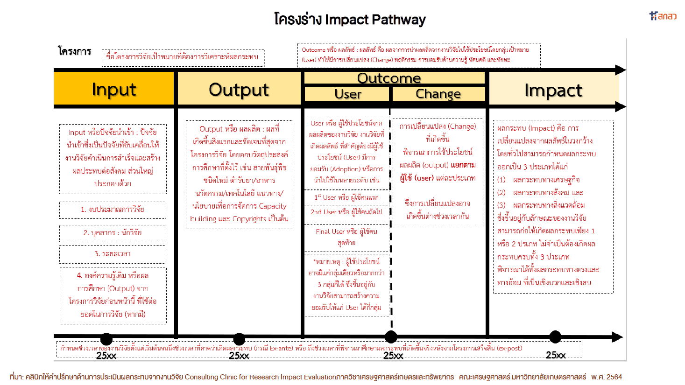

Signature...........................................Project Investigator
Date.............../................/...............
Type of Outcome and Definition
Type of Outcome | Definition
Publications | Academic works in print and electronic formats resulting from research, such as conference papers, research articles, review articles, academic articles, books, textbooks, dictionaries, and similar academic works.
Citations | The number of times a research work published in an international journal is cited, searchable via the Scopus database.
Research tools and methods | New tools or processes used by the researcher for experiments, testing, data collection, or analysis that did not exist before, have been disseminated, and are accepted, with evidence of others using them.
Research databases and models | A database (a system that collects data in one place) or a model (a representation of an object, process, relationship, or situation) developed from research, with evidence of it being used beneficially by others.
Next destination | Tracking the mobility and career advancement of personnel in Science, Research, and Innovation (SRI) projects funded by the NSRF after project completion, with supporting evidence.
Awards and recognition | Honors, awards, and societal recognition gained through professional work in SRI related to the project funded by the NSRF, with supporting evidence.
Use of facilities and resources | Utilization of tools, equipment, labs, and SRI infrastructure developed or procured with project funds, benefiting a wider range of users, with supporting evidence.
Intellectual property and licensing | Intellectual property refers to inventions or creations resulting in a new product or process, or any improvement thereof, including works created through one's own intellect, knowledge, ability, and effort in 9 legally defined categories (e.g., literary, artistic, musical, cinematographic works) without plagiarizing others, arising from SRI research funded by the NSRF, with supporting evidence.  Licensing refers to the rights owner granting another party permission to use rights arising from the research (e.g., to manufacture, sell, use) without transferring ownership, primarily for commercial benefit, with supporting evidence.
Spin-off Companies | The establishment of a company based on university technology or knowledge from research (technology transfer) to scale up research for commercial purposes, with supporting evidence.
New Products | Various types of products resulting from research, such as medical products, software and AI-related products, technical and technological products, agricultural and food products, and creative/artistic products. Creative products include tourism-related items like new tourist routes or programs. These must be significantly invented or developed within the project and capable of generating economic value, with supporting evidence.
Further funding | Grants received by the researcher to continue research based on the original project, by using the results to write a new proposal. It is important to provide information on the new funding source and budget, with supporting evidence.
Collaborations and partnerships | Collaborations or partnerships formed after the research project is completed, which are directly or indirectly related to the project. It is crucial to specify the output, outcome, and impact resulting from these collaborations, with supporting evidence.
Influence on policy, practice, plan and regulations | Actions taken to drive the use of research for policy purposes, or to establish new practices, plans, and regulations that lead to economic, social, cultural, environmental, or political changes beneficial to society and the nation, with supporting evidence. This must not be an action already specified as part of the research plan.
Engagement activities | Activities where the project leader and/or research team have communicated and integrated SRI with participant groups to promote research utilization, leading to broader impact, with supporting evidence. These activities must not be ones already specified as part of the research plan.

Definition of Impact
1. Economic: The use of research and innovation outputs (e.g., new products, improved products, processes, and services) for commercial production, leading to new investments, increased employment, reduced technology imports, or the development of new business models that create added value and increase efficiency in production and services. It could also be policy recommendations leading to measures that create economic value for the country. The Return on Investment (ROI) should be demonstrated.
2. Social: The use of knowledge from research and innovation to create change, empower community and local development, or push for policies that have a broad impact. The change or value must be clearly explainable. If the Social Return on Investment (SROI) can be demonstrated according to generally accepted principles, it would be beneficial.
3. Environmental: The use of knowledge from research and innovation to create positive environmental changes, improve people's quality of life, and lead to sustainability. This includes pushing for policies that have a broad impact. The change or value must be clearly explainable. If the Social Return on Investment (SROI) for social and environmental benefits can be demonstrated according to generally accepted principles, it would be beneficial.

